**Daily Scrum or Standup Meeting**

Team name: 5th Element

Scrum Master: Leonardo Craven

Date: November 10, 2021

| **Team Member** | **What did you do since the last scrum?** | **What do you plan to do before the next scrum?** | **What obstacles do you have?** |
| --- | --- | --- | --- |
| Leo | Nothing | Work on notification system for drink orders (done Wednesday, improvements done Friday) | None |
| Gavin | Finish menu population migration, finish current drink orders page for users | Work on order drinks page (done Friday) | None |
| Andrew | Finished navigation sidebar, resolving merge conflicts | Work on navigation sidebar, UI design | None |
| Brock | Worked on sponsor refunds | Finish sponsor refunds, finish company account migration (done Thursday) | None |

# Burndown

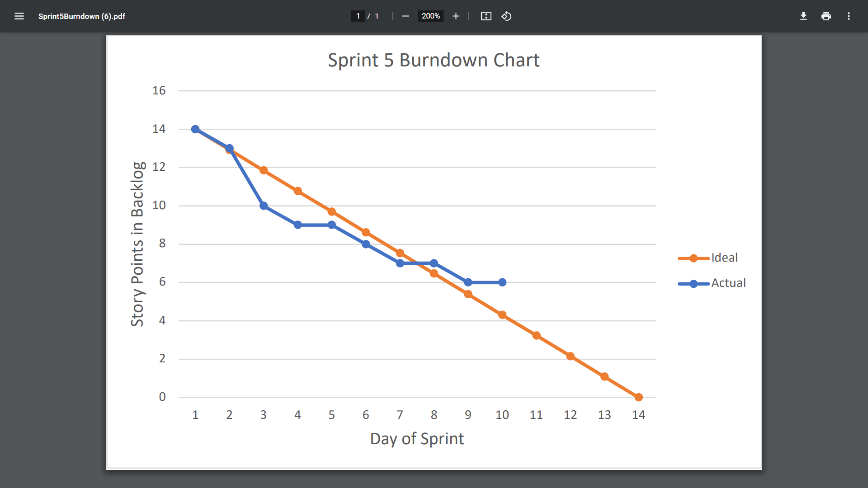

# Screenshot of you project board

